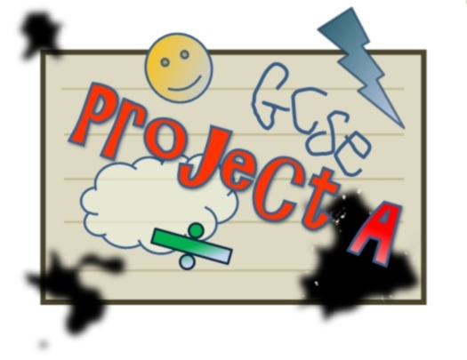

“A hands on approach to making revision what it should be… FUN! ”

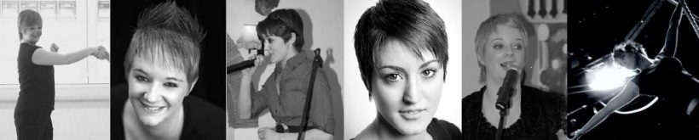
NAKED FRANK THEATRE

PROJECT A is proudly supported by The Miskin Theatre @ NWK College

IN THE BEGINNING…

Naked Frank Theatre
What do we do?

Naked Frank Theatre is a charity based physical theatre company based in Kent. Founded by Claire Louise Portelli and Carleigh-Ann Portelli , the company combines charity events with entertainment in an attempt to make a difference in the community.

Creating bold, hard hitting and truthful theatre! They aim to tell the untold and unnoticed stories of the world we live in; with innovative, honest and original work, devised by the cast!

"We don't just make theatre for the sake of theatre; all entertainment must serve a purpose."

PROJECT A?

THE BIG IDEA…

What is it?

“PROJECT A is a three month experiment, comprising of physical workshops that test the potential of using theatre skills as a means of helping year 11 pupils with ADHD revise for their GCSE’s. PROJECT A is a unique experience which ambitiously aims to challenge the educational system. Since the conventional teaching methods of ‘read and repeat’ have proven to be in-effective with many cases of ADHD we use a far more hands on approach; directly engaging the pupils and allowing them to make their own creative choices whilst still using the educational syllabus. They will be taught a variety of physical skills and will then be asked to put these into practice, creating small movement pieces in groups about selected material that they are learning in class.
PROJECT A hopes to create an open and dynamic learning environment to compliment the current school system.
PROJECT A can help every child succeed at any level of learning, as research has shown, the more active a child’s learning the faster that child’s development, not only in school but in every aspect of their life.”

ADHD…

What is it?

“Attention deficit hyperactivity disorder (ADHD) is a disorder that appears in early childhood. You may know it by the name attention deficit disorder, or ADD. ADD/ADHD makes it difficult for people to inhibit their spontaneous responses, responses that can involve everything from movement to speech to attentiveness.”
Characteristics of ADHD
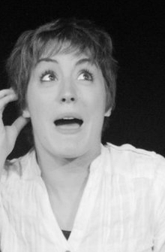
Help Guide
Melinda Smith, M.A., and Robert Segal, M.A.
Published: December 2012

“When many people think of attention deficit disorder, they picture an out-of-control kid in constant motion, bouncing off the walls and disrupting everyone around. But this is not the only possible picture.
Some children with ADD/ADHD are hyperactive, while others sit quietly—with their attention miles away. Some put too much focus on a task and have trouble shifting it to something else. Others are only mildly inattentive, but overly impulsive. ”

Help Guide
Melinda Smith, M.A., and Robert Segal, M.A.
Published: December 2012

The following statistics are taken from ‘ADDISS’ in a school servey called ‘Perspectives on ADHD’.

How does ADHD affect children in school?
36% of children are sent to see another teacher at least once a week.

Children were asked how these punishments made them feel – 77% said ‘angry’ and 62% said ‘fed-up’.

According to the children surveyed the most difficult things about living with ADHD at school are not being able to concentrate, 77%.

66% of the children surveyed said ADHD has some effect on their ability to get to school in the morning.

59% of the children surveyed said they wished they didn’t have to take medication all of the time. 10% of children feel they get picked on for taking medication at school.

Half of the children surveyed said that ADHD causes them problems making or keeping friends at school.

44% of the children surveyed said they feel they need medication all of the time at school, 17% feel they need it all of the time at home, 19% feel they need it in their social life.

Because of this, 69% of children are getting into trouble with teachers and 63% aren’t able to finish their work.

“Up to one in 20 children have ADHD and many are being put on medication. Scientists have raised concerns about the widespread use of ADHD medications.
Medication
A recent survey by the National Attention Deficit Disorder Information and Support Service (ADDISS) found the exclusion rate for children with ADHD was 10 times higher than that of those without. Some parents have told the BBC they were told to give their children medication or keep them at home, and that they often felt they were being denied a proper education.”
The BBC News Channel
All Out Productions
Cordelia Rayner
Published: Sunday, 22 October 2006, 08:36 GMT 09:36 UK
Naked Frank’s view on medication

“We believe that parents and teachers haven’t yet exhausted the possibilities of combating ADHD. Medication isn’t always the answer, but all too often children are being given tablets to curb some of their most precious qualities. We believe that by encouraging these qualities with a clear target, children can surpass expectations. By encouraging children to express their creativity as a natural outlet, they inevitably grow in confidence, determination and enthusiasm. These elements are key to a successful education and every child has the right to a successful education.”

THE REASON…

“I struggled to keep up with school work. I don’t have ADHD but I was always left behind and battling to organise my homework. I could never finish a task and was told I’d be kicked out for not keeping up.”
Carleigh-Ann Portelli, Founder Of Naked Frank Theatre

“I felt overloaded with work at school; but no one taught me how to organise or prioritise. Once I got to GCSE’s I had no idea how to revise. It was boring so I gave up. I didn’t get the grades I was predicted. Looking back I can see what was missing. School work was never fun or engaging.”
Claire Louise Portelli, Founder Of Naked Frank Theatre

“GCSE’s are a stressful time for teenagers and so many go through their education struggling against the system. PROJECT A opens a brand new door of opportunity for all pupils and helps them actively revise for the most important turning point in their lives so far.
Although PROJECT A’s methods are based around physical theatre we do not aim to create performers. We simply recognise the potential of using theatre skills as a means of revision.
We take an active approach to teaching so that pupils can have an exciting learning process.”
Naked Frank Theatre

PROJECT A…

Why choose PROJECT A?

- To boost self-esteem
By taking part in complex concentration exercises the pupils will gain confidence in their ability to focus on a challenging task.

- To use as an outlet for energy

PROJECT A is high energy, dynamic and crammed full of fun, physical revision techniques. The mood of the session creates the perfect environment for releasing tension and stress in a positive manner.

- Exercise
Research has proven that people with ADHD lack the essential Dopamine that is normally produced by the brain. Frequent exercise helps to keep ADHD sufferers calm and focussed because Dopamine (known as the happy hormone) is released after exercise.

- To engage with like -minded people
The students will gain vital skills in supporting others in a similar position. They will also feel encouraged by those who can empathise with their struggles and frustrations.

- For fun learning and revision

Many of the exercises explored in the workshops are used as methods of retaining information through physical movement.

- To help change the school image for pupils with learning difficulties
Pupils will be shown a range of new techniques to revise for their GCSE’s. The techniques help to stimulate their senses and therefore offer a more personal learning experience which can be tailored to suit the individual student.

- To practice self-analysis
By analysing their strengths and weaknesses within the workshops, they can make beneficial choices about how they choose to revise.

- To discover new career options
Research has proven that most ADHD sufferers excel in creative subjects. Performing may be an option they have never considered.

- To offer a brand new support system for teachers
Feedback with the teachers after each session will allow all teaching staff to keep track of progress made throughout the process. The workshops can be tailored at the request of the teachers to suit the criteria currently being covered in the classroom.

The PROJECT A Workshop

How long are the workshops?

PROJECT A consists of two workshops set out over two consecutive days. (This allows for refection time and preparation in between.) Both consecutive days are two hours long with a 10 minute snack break after 55minutes.
What type of skills will the pupils learn?

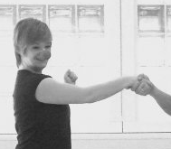
The First Day: The Meeting
The pupils will get to know their strengths and weaknesses through a series of concentration games with physical challenges as obstacles.
They will learn to express themselves through challenging acting games that will engage their impulsiveness and creativity.
Trust exercises will help them to form bonds with one another.
They will then be taught a variety of physical theatre movement techniques’ including gestural work, ensemble practice and free movement. This work can change depending on the pupils and the group’s physical capability.
The pupils meet and play some brief warm up games together. Each pupil will then describe a piece of work they are struggling with in class. (This may be a poem they have to learn for English, a physics equation or even, learning the pentatonic scale in music?)
The Second Day: The Discovery
At this point they will be taught how to combine text and movement by using their entire body to create a movement score. This will help them to associate links between topics and improve their 'muscle' as well as 'mental' memory when revising. We will teach a variety of techniques incorporating song with complicated subjects; consequently injecting fun into hard, boring revision.

The workshop will end with a short question and answer session and those who wish to may present their work.

By the end…
When the pupils leave the workshop they will be equipped for revising in a fun and playful way, which is unique to them. Revision is no longer an obstruction to their learning but a hurdle in which they can jump over.
We aim to see an improvement in their enthusiasm for difficult subjects, their overall concentration level in class and inevitably an improvement in their mock tests before their GCSE’s.
Naked Frank Theatre are available if any support is needed after the workshops are completed. We are also available for further workshops.
Naked Frank are also available to help in your Drama department with Acting/ Movement support.
Leading up to the workshop…

Naked Frank will be in touch frequently to discuss your requirements; we offer a tailored service to every school.

We would preferably need to ‘sit in’ on a class to understand more about the pupils we will be working with, or if this isn’t possible we would love to speak to a support teacher at the school who works closely with the students we will be teaching, so we can assess their problem areas and work towards their needs. (The students chosen to take part in PROJECT A do not necessarily have to suffer from ADHD. We would also like you to select students that are clearly struggling to keep up in class or are falling behind with work.)

Naked Frank would then love to schedule an informal meeting with the pupils on a date before the workshop, to get to know them and understand how they feel about their school life and their attitudes towards revising in general. They can also start to think about which subject they would like to work on in the workshops.

What’s next for PROJECT A?

PROJECT A is a three month experiment, testing the potential of using physical theatre skills in schools, to help children with ADHD revise for their GCSE's. After this period we will analyse the success of the project and take the steps to improve our methods. By continuing our work in schools, we hope to give PROJECT A a more permanent place in the U.K educational system.

Questions for Naked Frank Theatre

If you are interested in working with NAKED FRANK THEATRE, please email us at nakedfranktheatrecompany@email.com or give us a call on 07851781915. For more general information about NAKED FRANK THEATRE please visit our website: www.nakedfranktheatre.com

Useful Links
- ADDISS ‘Perspectives on ADHD’
- ADD/ADHD Help Guide, Melinda Smith & Robert Segal
- The ADHD Dilemma For Parents, Cordelia Rayner
- Giving Kids With LD & ADHD An Opportunity To Learn, Wrightslaw
- Exercise For Children With ADHD, Hansa. D. Bhargava

